p614 Chodera 96-well expression report updated 08/05/2016

Due to poor results from the initial pulldown, especially for the Abl kinases, the Ni pulldown was repeated on a duplicate expression plate. This time, a different solubilization/protein extraction reagent was used: Solulyze, with 20 mM HEPES pH 7.5, 400 mM NaCl, 20 mM imidazole, plus DNAse/RNAse/protease inhibitors. This gave much improved yields for many of the Abl kinases, although there are still many missing, presumably due to severe insolubility.

Results

Caliper gel image: see file p614 pulldown_Caliper Solulyze.jpg
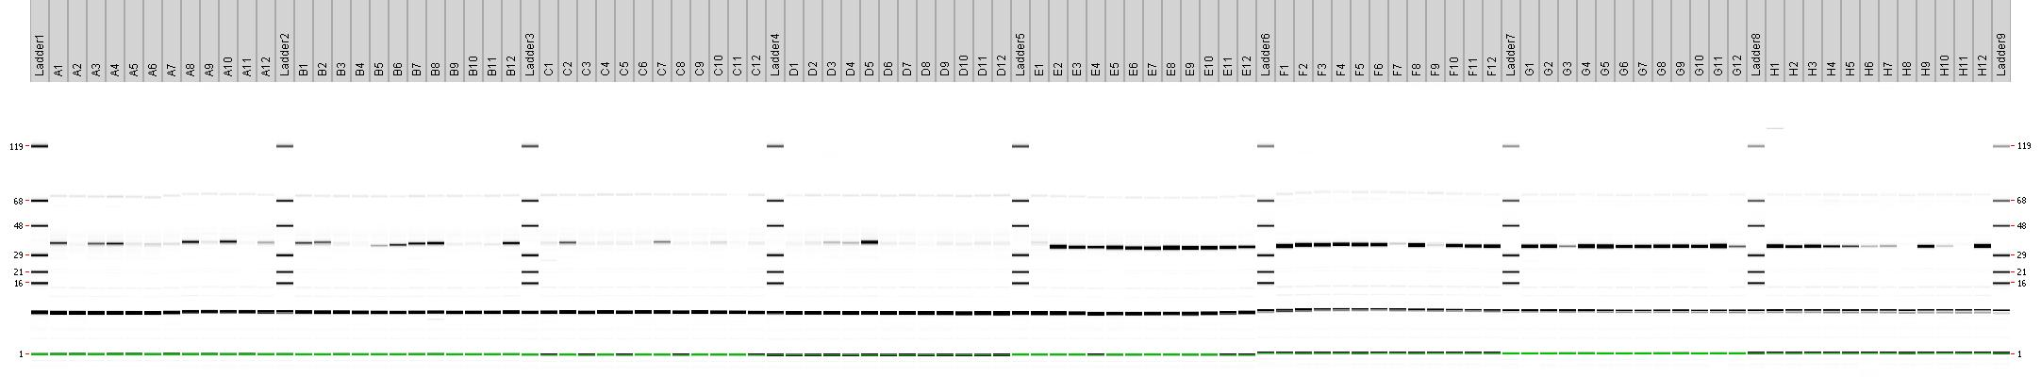

Target protein concentrations from Caliper analysis

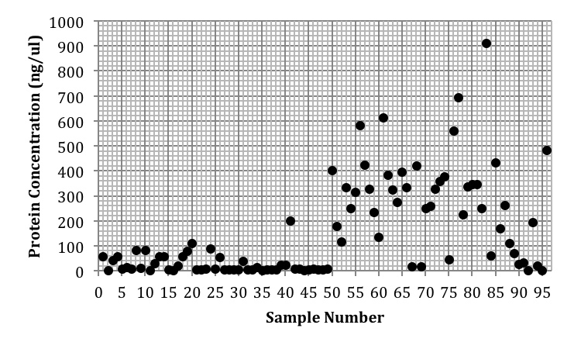

Samples 1-49 are Abl, 50-96 are Src. Samples 1 and 50 are the ‘wild-type’ versions of those proteins as used in previous work (p470).

For the Src proteins, there was not an obvious increase in yield when using the Solulyze extraction reagent: for some mutants the yield was improved, for others it was reduced. For several, the yield was basically zero with either extraction reagent, suggesting that these mutants are very poorly soluble indeed.

For the Abl proteins, many mutants are still undetected in the Ni pulldown, but 11 are present at concentrations similar to or higher than that of the wild-type. A further 8 are detectable, but at concentrations significantly lower than that of the wild-type protein. The very large increase in yield for sample D5 (Abl-I403T) appears to be genuine, and not an artifact of analysis or cross-contamination.

Full dataset in spreadsheet: 2016 08 05 p614 kinase QC expression summary.xls
Worksheets
“Solulyze extraction” gives protein sizes and concentrations for the repeated Ni pulldown using Solulyze.
“Compared to BugBuster” compares protein sizes and concentrations between the two extraction methods.
“Yields Compared” has some additional comparison charts.

Samples eluted by both methods will be shipped to you on dry ice. Samples (approx. 80 μl) in both blocks are in the same buffer: 25 mM HEPES pH 7.5, 400 mM NaCl, 400 mM imidazole, 10% glycerol.

